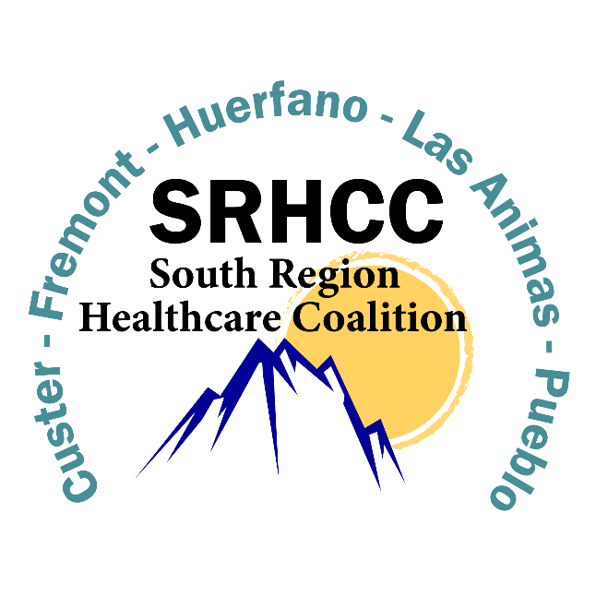

SRHCC Public Information Officer (PIO) Training Plan 2021-2022
The South Region Healthcare Coalition has compiled the following information for coalition member organizations and their designated Public Information Officers who wish to pursue additional training in this field to further their capacity to respond and support the health and medical efforts of the South Region during an emergency.
Per the 2021-2022 SOW, Objective 1, PA#4, SA #9 “The Contractor shall implement a training plan to provide PIO training.” and Deliverable #29 “The Contractor shall submit dates and attendance on the PIO training plan.”
Moving forward, the SRHCC leadership will continue to coordinate with PIO’s in the region and respond to needs as appropriate. This will include promoting training and exercise opportunities for the coalitions’’ members, supporting the inclusion of messaging objectives in future exercises, and continuing to build cross jurisdictional relationships.
This information has been sent to all coalition members and can be found on the SRHCC Website. All coalition members have been instructed to visit this website during quarterly member meetings.
https://www.southregionhcc.org/training-and-exercise/
- Note: Click on the link to the website. Then Click on the public Information Officer Training Plan Tab
Please see the following for your reference and record.

Crisis and Emergency Risk Communication (CERC)
“Crisis and Emergency Risk Communication (CERC) training can help responders and public health professionals prepare to communicate in an emergency. The CERC program offers training in online, webinar, and in-person formats. It is our hope that participants will find at least one of these options to be accessible and convenient.” - U.S. Department of Health & Human Services, https://emergency.cdc.gov/cerc/training/index.asp
Resources
- CERC Manual - 2014
- Templates and Tools
- CERC Presentations
Training
- Crisis and Emergency Risk Communication (CERC) Online Training
- Continuing Education for CERC Webinars/Calls
- Crisis & Emergency Risk Communication Webinars

Additional PIO Training
- CO Train - IS-29.A: Public Information Officer Awareness - ID 1087762
- CO Train - IS-42 Social Media in Emergency Management - ID 1034415
- CO Train - What Your PIO Wants You To Know: Webinar - ID 1089018
- CO Train - Risk Communication (Basics of Public Health Preparedness, Module 10) - ID 1046401
- CO Train - Preparedness Summit 2014: Video Podcasts " Social Media Preparedness and Community Disaster Information" - ID 1051125
- DEMA EMI - Communicating Effectively in an Emergency – MPIV7 MGT-902-V7
- FEMA EMI - G290 – Public Information Officer – Basic
- FEMA EMI - G291/E-L0387 – Joint Information System/Joint Information Center Planning for Tribal, State and Local PIOs
- FEMA EMI - E/L0388 Advanced Public Information Officer
- FEMA EMI - Master Public Information Officer Program
- For more information on the Public Information Officer training program, contact FEMA-Master_PIO_Program@fema.dhs.gov

